Blog Nest
Brainstorming & Ideation Template

Date | 21 September 2026
Team ID | SWTID-2026-9317
Project Name | Blog Nest
Maximum Marks | 4 Marks

Blog Nest Documentation:
Blog Nest is presented as a blogging platform concept where users can create and manage blog content, add relevant images, publish posts, and read or engage with published content. The documentation below follows the same step-based structure as the supplied brainstorming and idea-prioritization template.
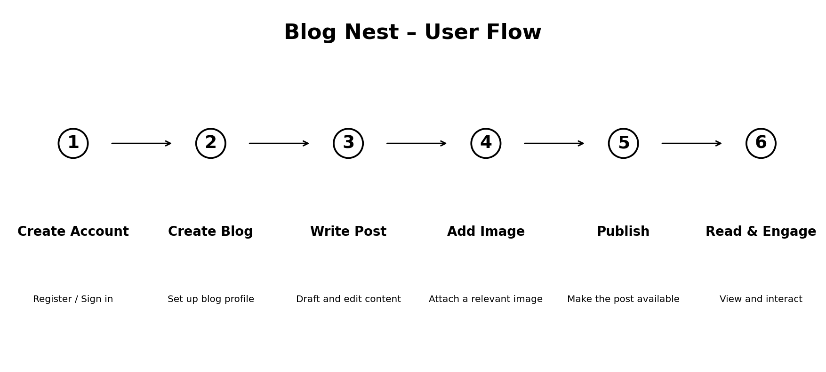
Figure 1. Blog Nest user flow
Step-1: Team Gathering, Collaboration and Select the Problem Statement
Problem Statement: Readers and writers need a simple, organized space where blog content can be created, illustrated with images, published, and accessed in a clear workflow.
Project Goal: Design Blog Nest as a focused blogging environment that makes the journey from creating a blog to publishing and reading posts easy to understand.
Step-2: Brainstorm, Idea Listing and Grouping
Idea Group | Description
User Management | Sign up, sign in, and basic user profile management.
Blog Creation | Create a blog space with a title, description, and basic identity.
Post Creation | Write, edit, save, and organize blog posts.
Image Support | Add a relevant image to make posts more engaging.
Publishing | Publish completed posts so they can be viewed by readers.
Reading Experience | Browse posts in a simple and readable layout.
Engagement | Allow readers to interact with posts where supported by the project.
Step-3: Idea Prioritization
Priority | Feature | Suggested Priority Level
1 | Core Blog & Post Creation | Essential
2 | Image Upload / Display | Essential
3 | Publish & View Posts | Essential
4 | User Authentication | Important
5 | Reader Engagement | Optional / depends on project scope

Reference Structure
This document preserves the supplied template's three-step organization: team/problem selection, brainstorming and grouping, and idea prioritization.

